Aluminum Casting Furnace Build 8/10/16 AAC

Scope
I intend to build a furnace that is capable of melting aluminum for the purpose of casting. The goal of this project will be to produce 20 one pound billets of aluminum.

The Components
- Furnace
  - Use old water heater tank (its free)
  - DIY Refractory cement (Option A)
    - http://www.backyardmetalcasting.com/refractories.html
    - The refractory mix is composed of Portland cement (1.5 parts), silica sand (2 parts), perlite (1.5 parts) and fireclay (2 parts).
    - I need 2.6 Cubic Feet but will plan for 4 cubic feet
    - Cost $101.32
  - Insulating Fire Brick (Option B)
    - Common Fire Brick size is 4.5 X 3 X 9 inches
    - A total of 36 Bricks will be needed to complete the furnace. I will figure for 40 bricks to account for mistakes.
    - I will still need refractory cement
    - Cost ?
- Plinths
  - Cast with same material as furnace
- Crucible
  - Research options
  - Possible used my old steel scuba tank
- Tool to remove the Crucible from the furnace
  - Will build after I decide on the crucible
- Tool to poor the Crucible
  - Will build after I decided on the crucible
- Propane/Oil Burner
  - Research options
  - Really like the burner used by Doug from SV Seeker
    - http:/svseeker.com/casting_furnaces.htm
- Forms for Aluminum Billets
- Scrap Aluminum
  - Old lawn mower engine

The Plan
- Refractory Cement
  - I need 2.6 Cubic Feet but will plan for 4 cubic feet.
    - 1.5+2+1.5+2 = 7parts
    - 4/7 = 0.57cubic feet per part
    - Total Cost = $101.27
Refactory Cement Materials
Description | Source | Part# | Qty Needed | QTY Sold In | Pice per | QTY to Buy | Total
Portland Cement | Lowes | 10352 | 161lbs | 94lbs | $10.30 | 188lbs | $20.60
Silica Sand | Lowes | 230025 | 114lbs | 100lbs | $17.35 | 200lbs | $34.75
Perlite | Home Depot | 216847 | .855ft^2 | 2ft^2 | $16.97 | 2ft^2 | $16.97
FireClay | Ceramic Store Inc | n/a | 97.72LBS | 100lbs | $29.00 | 100lbs | $29.00
 |  |  |  |  |  | Total | $101.32

  - Portland Cement (1.5 Parts)
    - Can be Purchased at Lowes ($10.30 / 94lbs (.5ft^2)
      - Part# 10352
      - 188lbs for $20.60
    - 1.5 parts*0.57ft2 = 0.855ft2
    - 0.86ft2 * 188lbs = 161lbs
  - Silica Sand (2 Parts)
    - Lowes (order) 100 lbs / cubic foot ($17.35 / 100lbs)
      - Part# 230025
      - 200lbs for $34.70
    - 2 parts*0.57 = 1.14ft2
    - 1.14ft2 * 100LBS = 114lbs
  - Perlite (1.5 Parts)
    - Home Depot ?lbs / cubic feet ($16.97 / 2 cubic feet)
      - Sku# 216847
      - 2ft2 for 16.97
    - 1.5 parts*0.57ft2 = 0.855ft2

  - Fireclay (2 parts)
    - Ceramic store Inc in Houston
      - 81.34LBS /cubic feet ()
      - 100lbs for $29.00
    - 2 parts*0.57 = 1.14ft2
    - 1.14ft2 * 81.34LBS = 92.72lbs
- Insulating Fire Brick
  - Common Fire Brick size is 4.5 X 3 X 9 inches
  - A total of 36 Bricks will be needed to complete the furnace. I will figure for 40 bricks to account for mistakes.
  - Furnace Dimensions
    - OD 16inches
    - ID 10inches
    - Chamber depth 16 inches
  - If I take the OD and figure the circumference of the furnace and divide be the width of the brick I should be close to the number of bricks I will need to make one layer.
    - 16 OD X 3.14 = 50.26 inches around
    - 50.26inches around / 4 inch brick = 12.56
    - 13 bricks will be needed per layer
  - The chamber Depth is 16 inches so I will need two layers of 13 Bricks.
    - 26 Bricks to complete the walls
  - The Chamber bottom will need one layer of bricks
    - 4.5 inches * 9 inches = 40.5 inches square per brick
    - 16 inch OD / 2 = 8 Outer Radius
    - 8 OR * 8 OR *3.14 = 201.06 inches square
    - 201.06 in^2 / 40.5 in^2 = 4.96
    - Five Bricks will be needed for the bottom
  - I will plan to use the same count for the lid as I do for the bottom.
    - I will need 5 Bricks for the lid
  - The Furnace will need a total of 31 Bricks To complete
    - (13 * 2) + (5 * 2) = 36 Bricks

Propane/ Oil Burner
- http://svseeker.com/casting_furnaces.htm
  - Parts Patriot Supply
    - Nozzle Adapter ($24.00)
      - Manufacturer: DELAVAN
      - Product Code: 17147
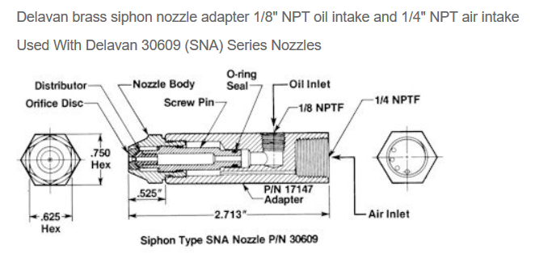
    - Nozzle ($24.00)
      - Manufacturer: DELAVAN
      - Product Code: 30609-8
- 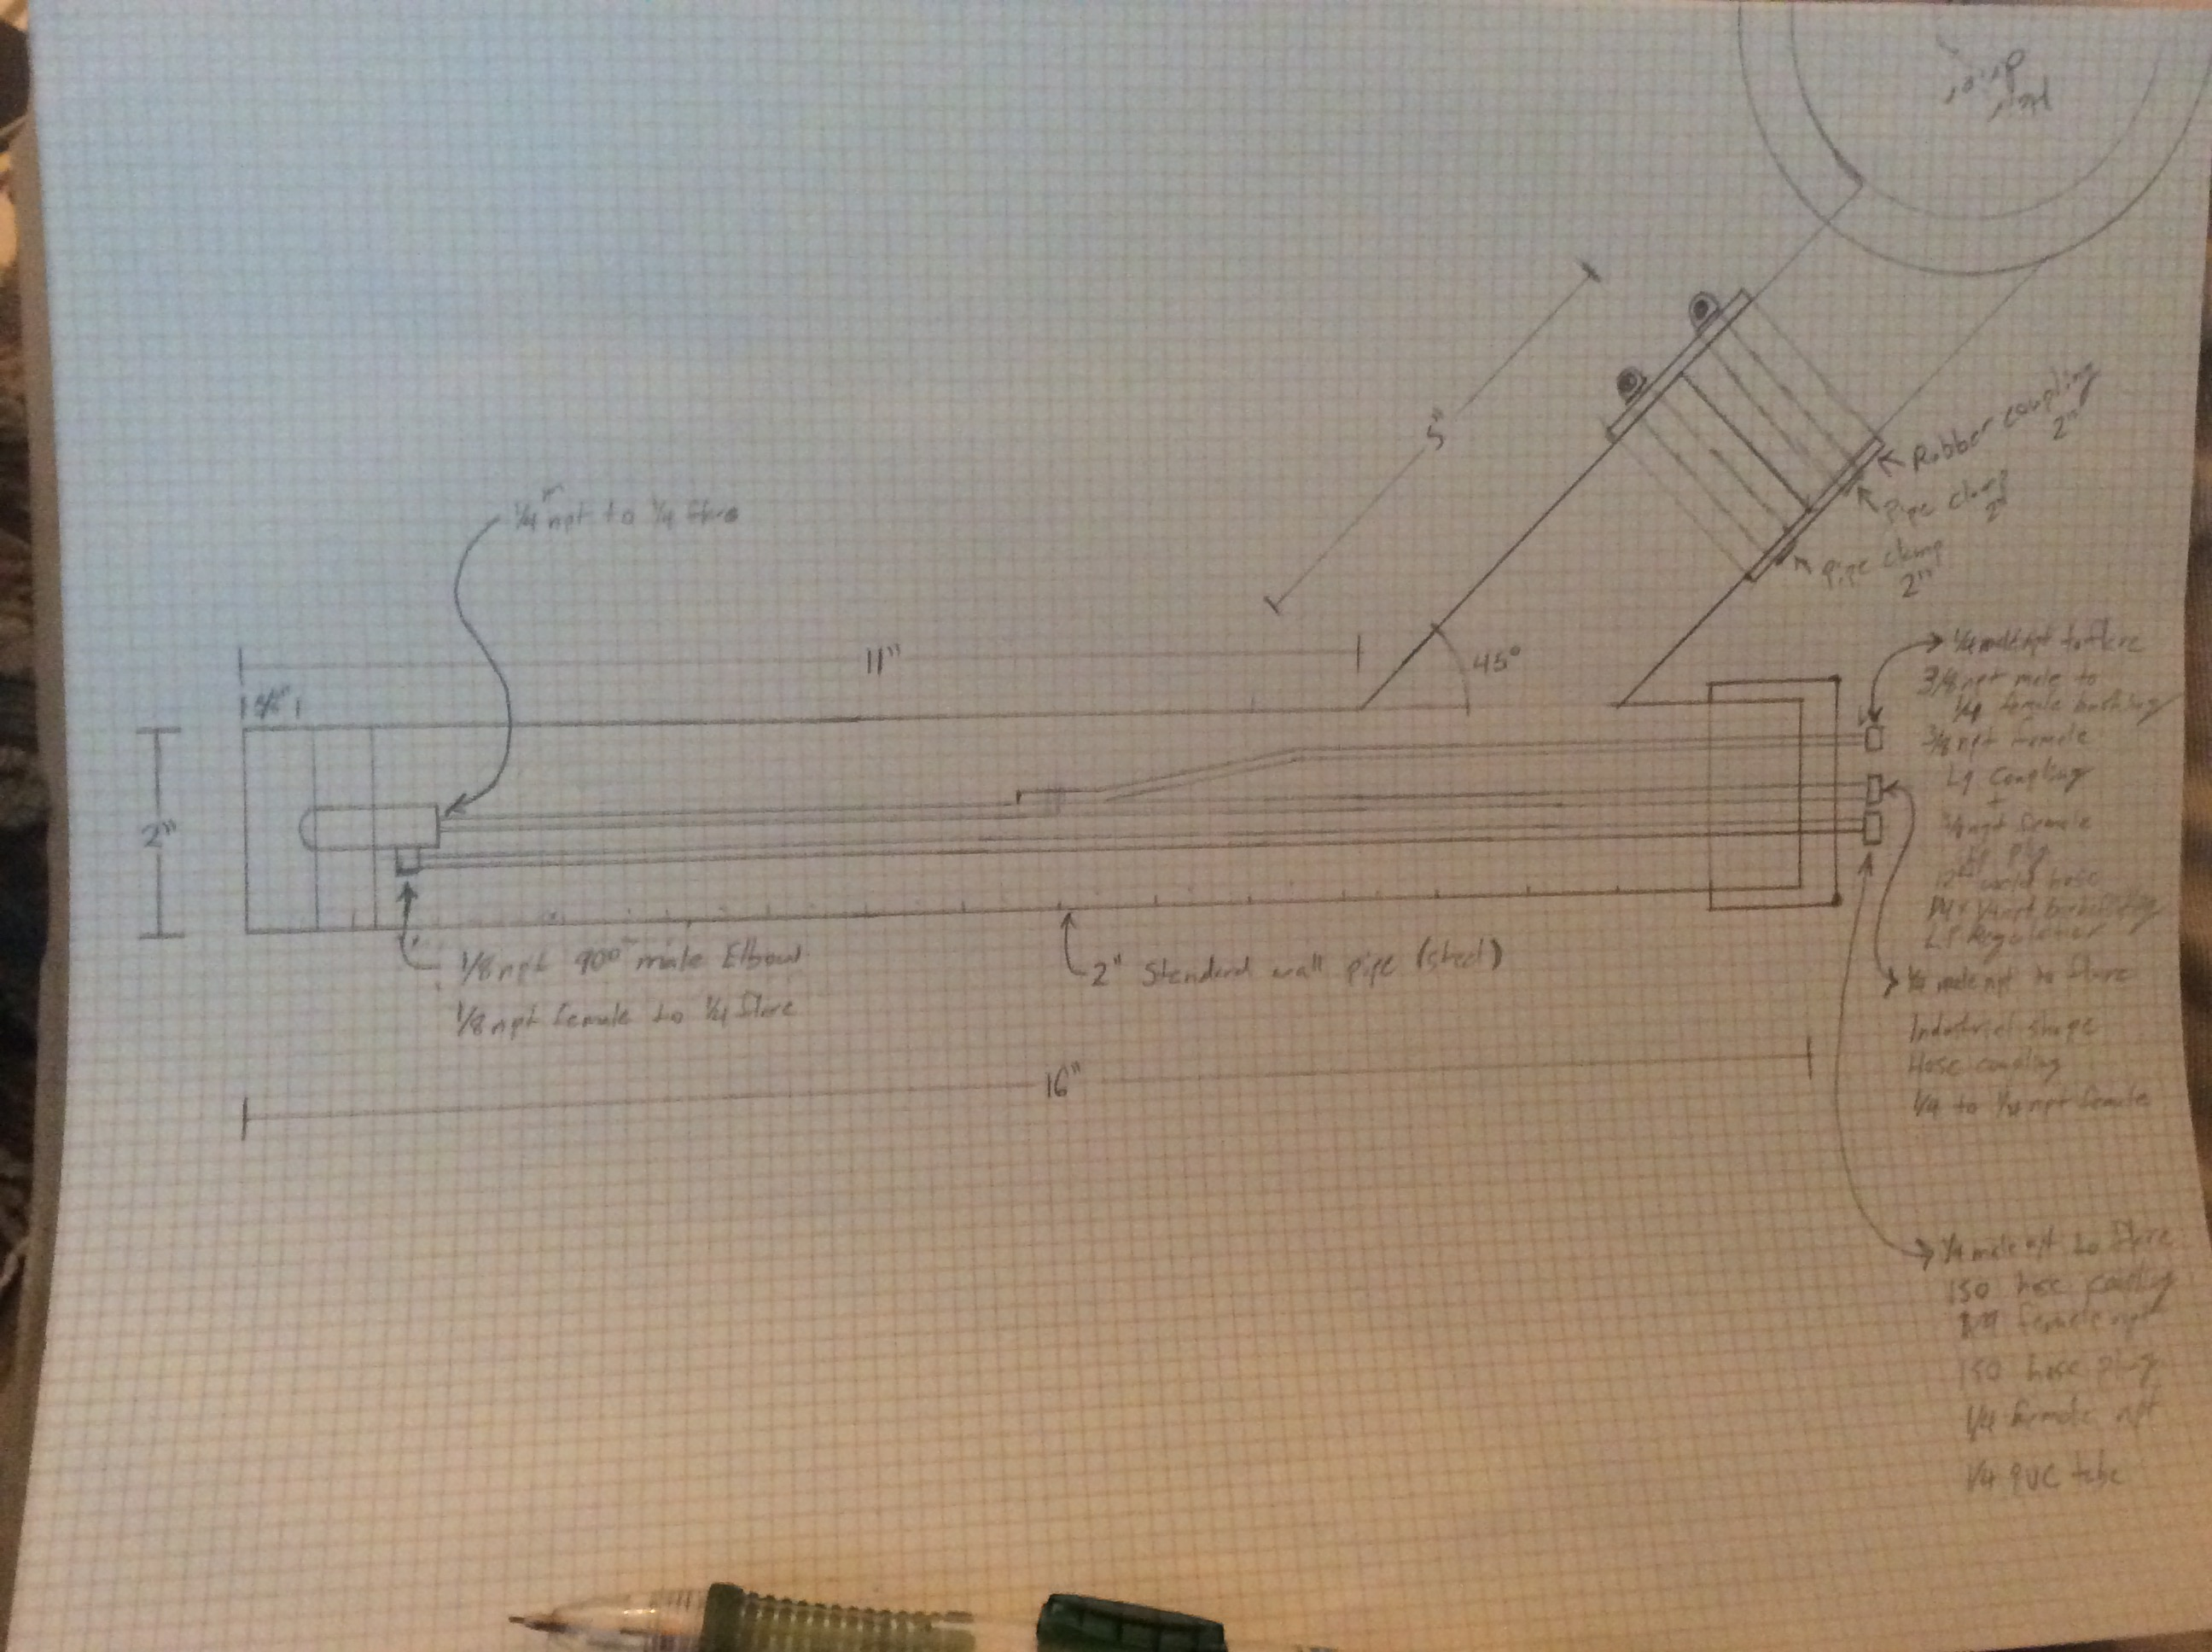
- I assembled a parts list with part numbers and quantities from Mcmaster-Carr. It is quite pricy so I will look at other sources and cheaper options for materials and connectors. This First list is sort of an Ideal build list.
  - Parts List
Feed line | Quantity | Description | Part# | Price | Extended
Air | 1 | Industrial-Shape Hose Coupling, Size 1/4 Zinc-Plated Steel Plug, 1/4 NPTF Female End | 6534K56 | $1.32 | $1.32
All | 4 | Steel 37 Degree Flared Tube Fitting, Adapter for 1/4" Tube OD x 1/4 NPTF Male Pipe | 50695K162 | $1.46 | $5.84
All | 1 | Smooth-Bore Seamless Steel Tubing, 1/4" OD, 0.049" Wall Thickness, 6 Feet Long | 9220K321 | $10.46 | $10.46
Null | 1 | Standard-Wall Steel Pipe, 2 Pipe Size, 3' Length, Unthreaded | 7750K196 | $46.45 | $46.45
Oil | 1 | Compact Extreme-Pressure Steel Threaded Fitting, 1/8 Pipe Size, 90 Degree Male Elbow | 50925K117 | $3.83 | $3.83
Oil | 1 | Steel 37 Degree Flared Tube Fitting, Straight Adapter for 1/4" Tube OD x 1/8 NPTF Female | 50695K171 | $1.95 | $1.95
Oil | 1 | ISO-A Hose Coupling, Zinc-Plated Sleeve-Lock Socket, 1/4 Coupling, 1/4" NPTF Female | 51335K51 | $21.94 | $21.94
Oil | 1 | ISO-A Hose Coupling, Zinc-Plated Plug, 1/4 Coupling Size, 1/4" NPTF Female | 51335K61 | $8.38 | $8.38
Oil | 1 | PVC Tubing for Fuels and Lubricants, 1/4" ID, 3/8" OD, 25 ft. Length | 5187K63 | $16.25 | $16.25
Oil, LP | 2 | Compact Extreme-Pressure Steel Threaded Fitting, 3/8 Male x 1/4 Female Pipe Size, Hex Head Bushing | 50925K345 | $1.50 | $3.00
Propane | 1 | Hose Coupling for Natural and LP GAS, Socket, 3/8" NPT Female, 3/8" Coupler | 6053T11 | $23.25 | $23.25
Propane | 1 | Hose Coupling for Natural and LP GAS, Plug, 3/8" NPTF Female, 3/8" Coupler | 6053T12 | $11.18 | $11.18
Propane | 1 | Gas Regulator for Propane, CGA #510 Male Inlet, Standard Duty, 1-Stage | 7897A66 | $141.09 | $141.09
Propane | 1 | 12 Feet Long Hose for Torch-to-Propane Tank Adapter | 7976A34 | $41.46 | $41.46
Propane | 1 | Brass Barbed Tube Fitting for Vacuum, Straight for 1/4" Tube ID x 1/4 Male Pipe Size | 44555K132 | $3.03 | $3.03
 |  |  |  | Total | $339.43

